**Secondary Data**

Step 1: - The system will allow the Central Admin to upload all secondary data (of different formats) for which PHFI pays subscription fee.

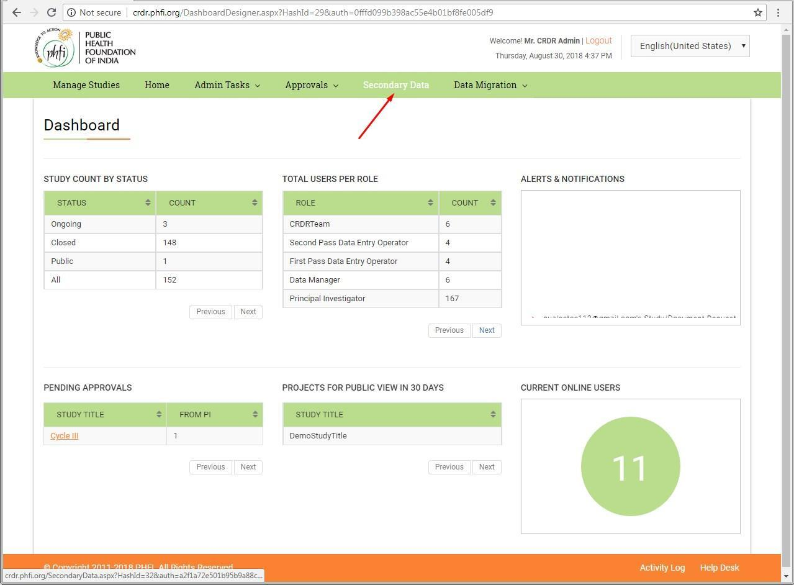

Step 2: - The system will allow the Central Admin to 'Add Subscription' and ‘Add data set” to the subscription.

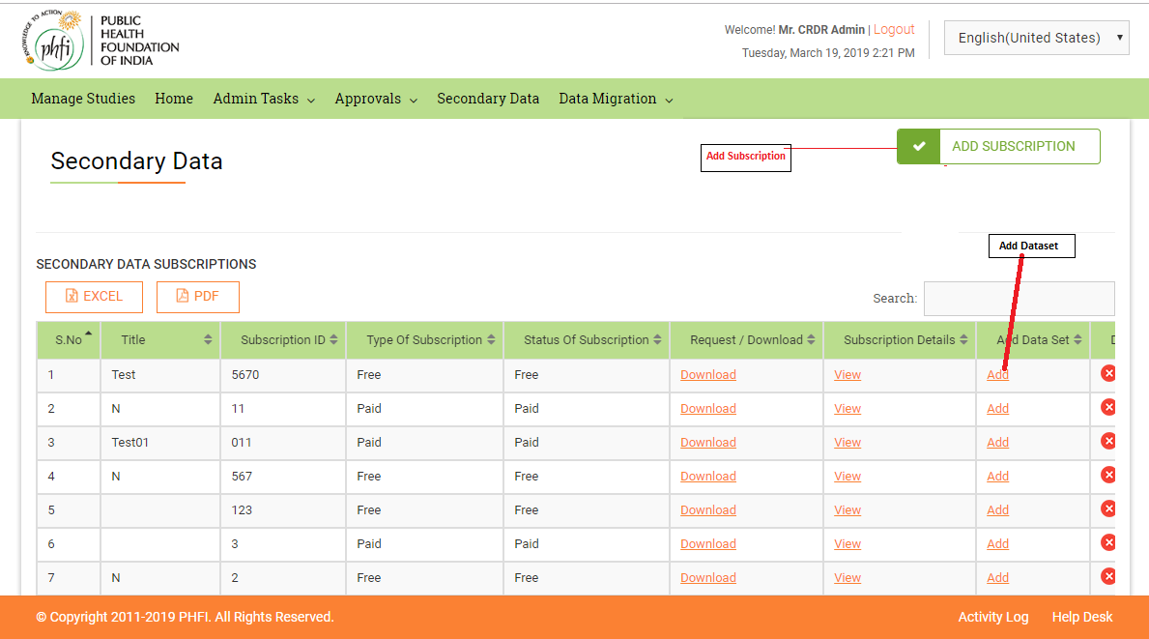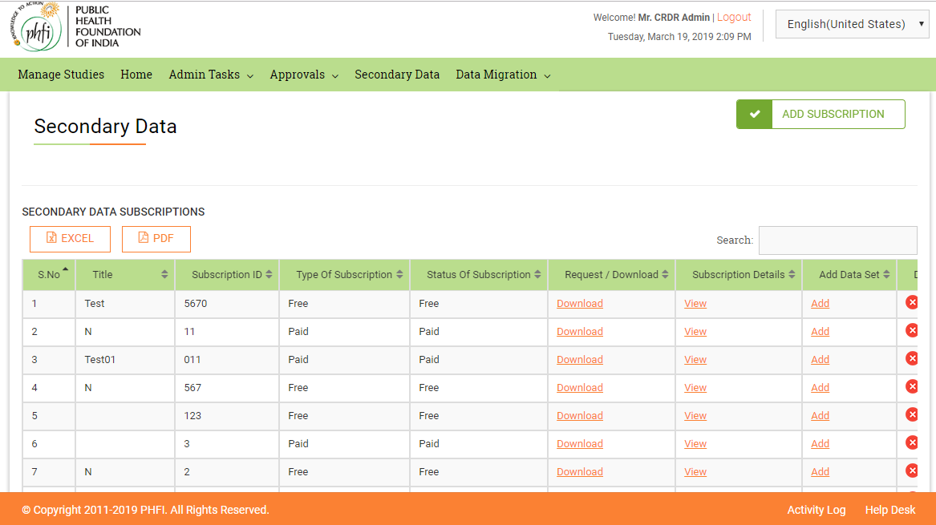

The system will allow the Central Admin to 'Add data sets' for the subscription data, if required.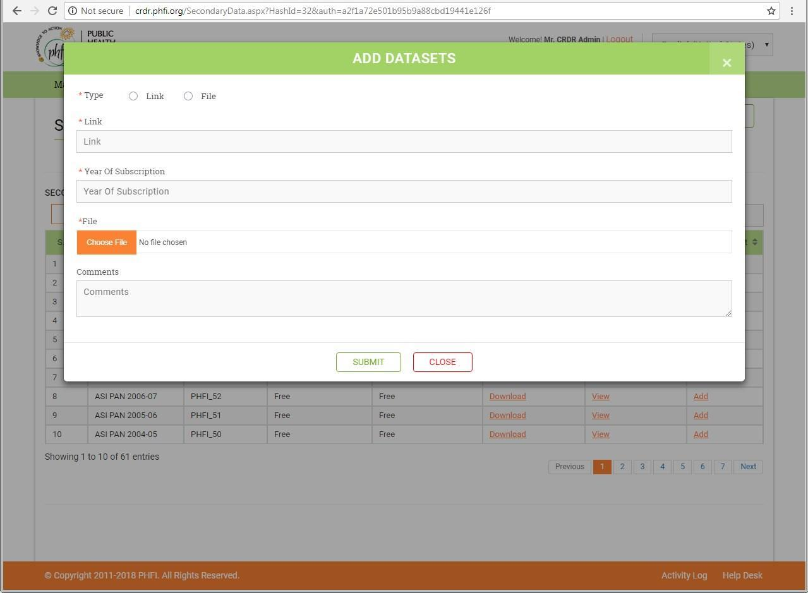

Step 3: - To add a new subscription, the Central Admin should enter the following details: - Subscription Unique ID - Type of the Subscription (paid/free) - Valid from and to.. count of users. - Year of Subscription - No. of Subscriptions/Licenses - Project Code - Title - Type - Comments - Keywords/Metadata

Step 4: - The system will display the following details of the secondary data: - Project Code - Title of the Project - Category - Subscription ID - Type of the Subscription (paid/free) - Comments - Add Data Sets

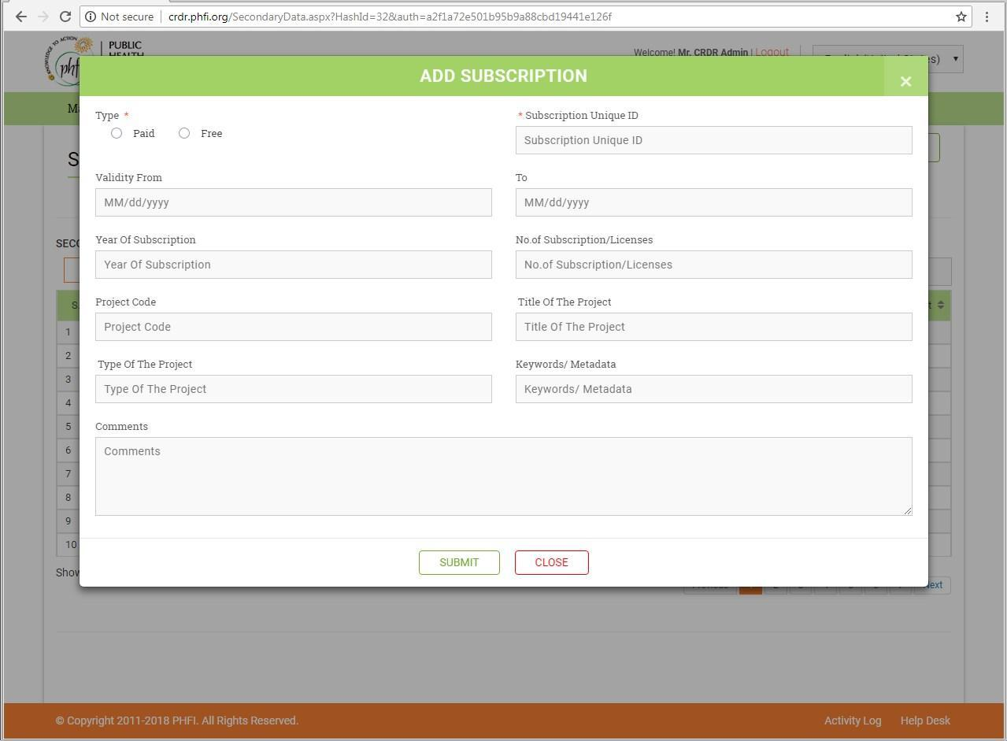

Step 5: - The system will ask for the following details, if a data set needs to be added for an existing subscription:

1. ”Year of the Subscription”
2. “Browse” and “upload a file”, If it's a file,
3. or, Enter the “URL”, if it's through a link
4. Comments

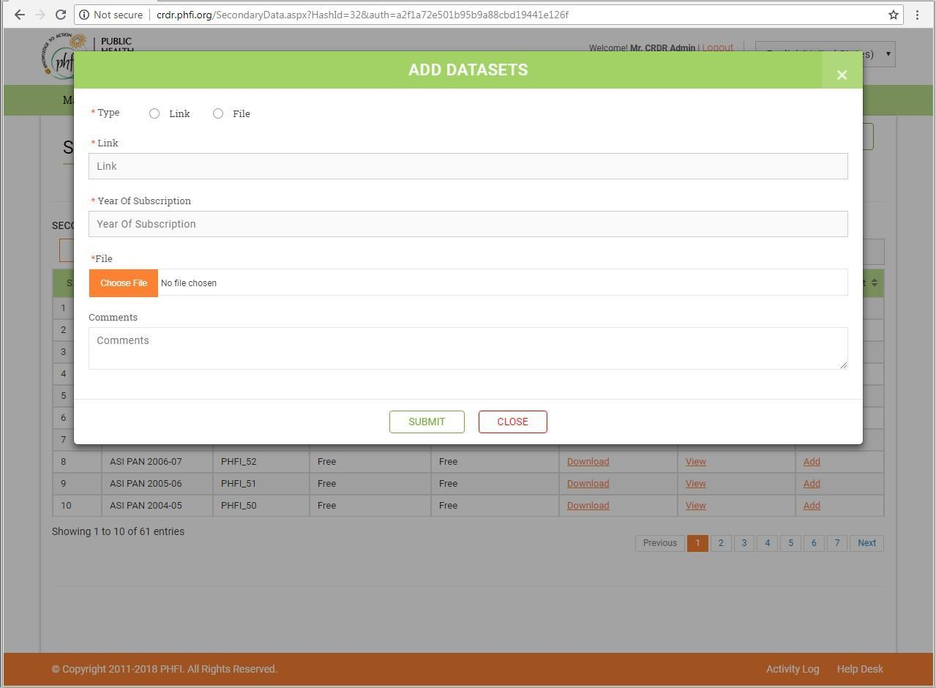

Step 6: - The system should allow all the users to view/download the freely available secondary data, which will be provided as links. For the paid secondary data, users will have to request for accessing the data.

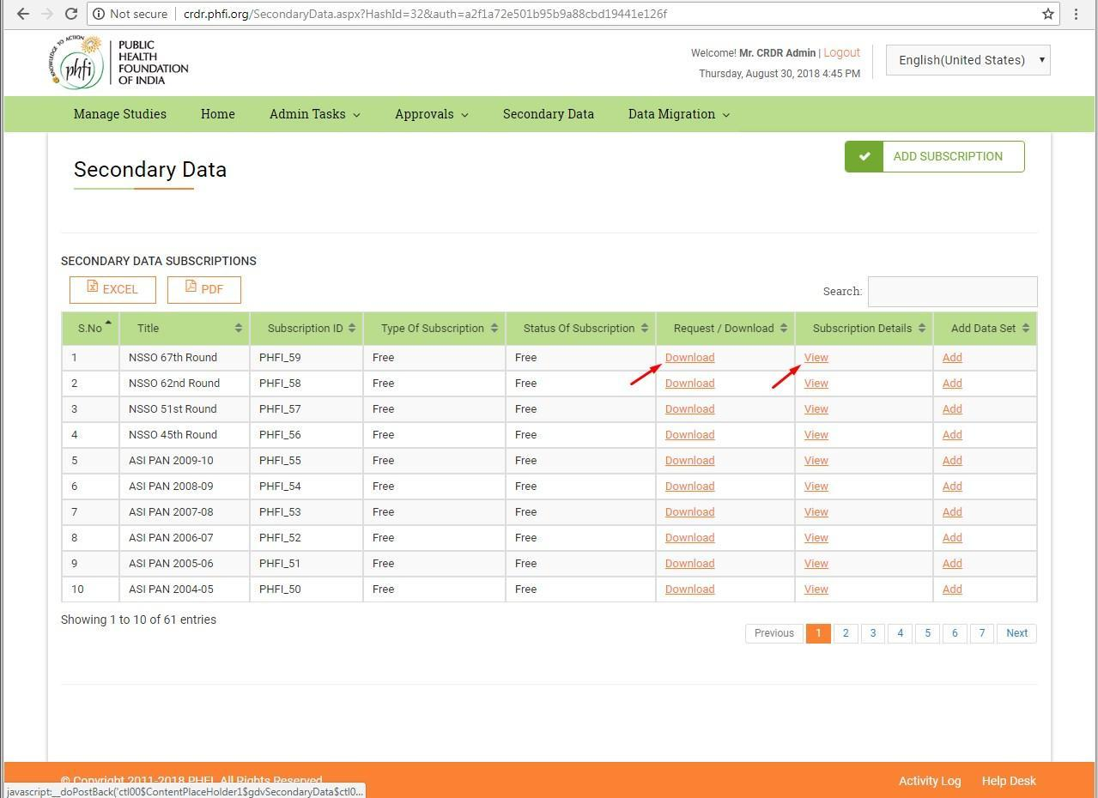

Step 7:- The Central Admin can reivew the requests from the users for accessing the paid secondary data. These requests can either be accepted or declined (reason to be provided, if declined).  
The following details are available on this page:-

1. ProjectCode
2. TitleoftheDocument
3. Project
4. Category
5. Subscription Unique ID
6. Comments(Reasonforaccess)
7. Action Taken (Accepted/Declined/Reason, if declined)

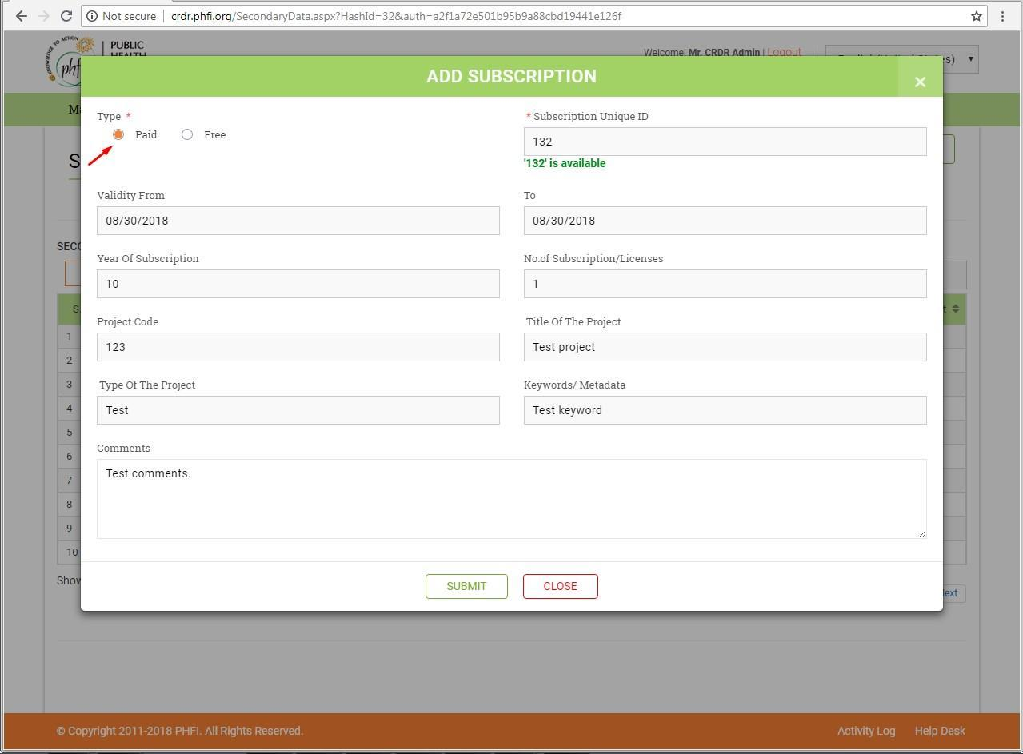

Result:- Pass.

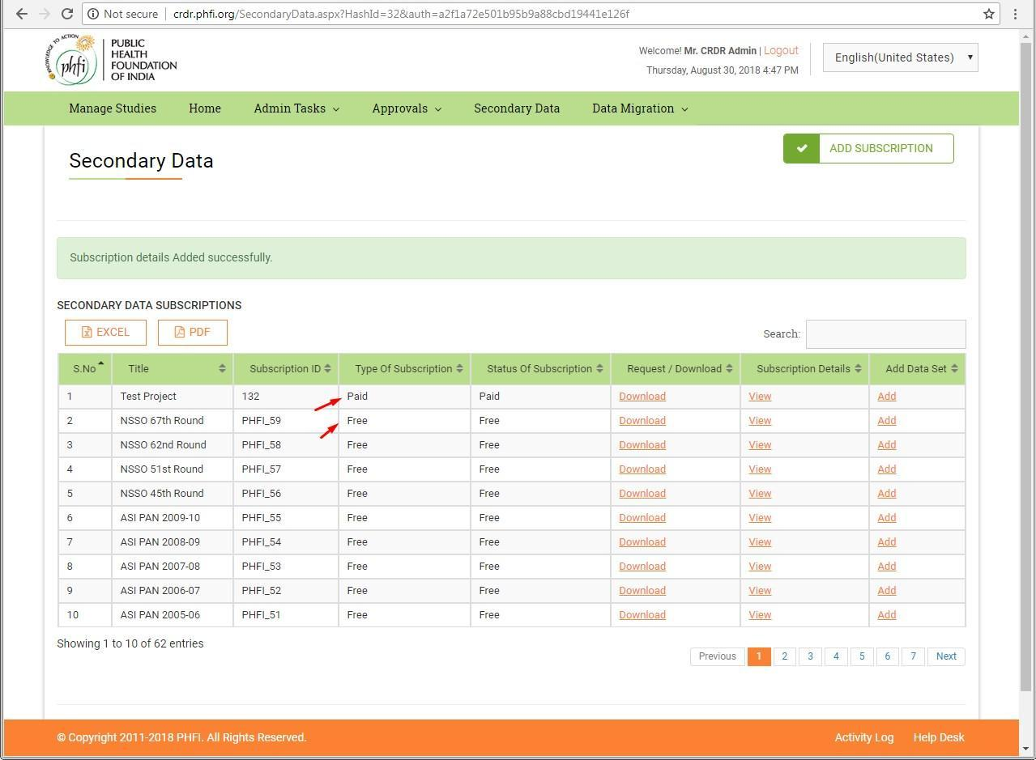

Steps To delete Secondary Data

Step 1:- Login as Principle Investigator to the CRDR homepage in Live.

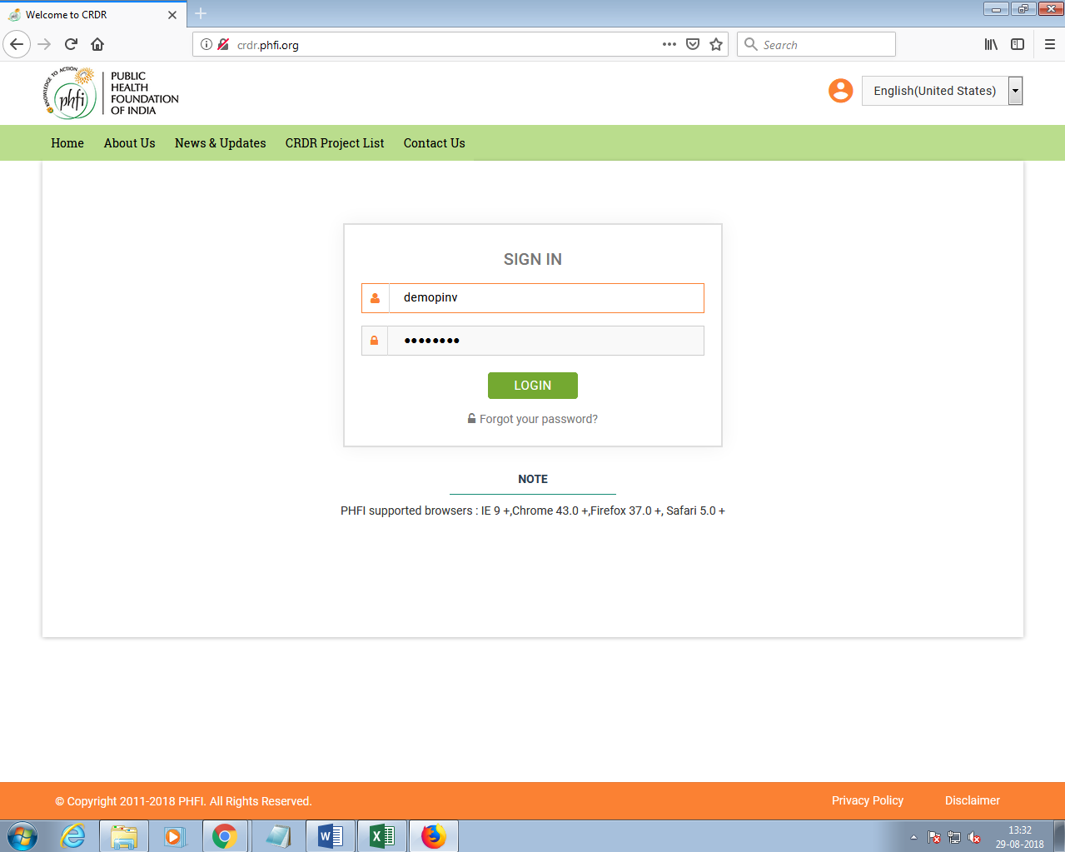

Result: Pass

Step2:- System should display the Delete option should be added for secondary data.

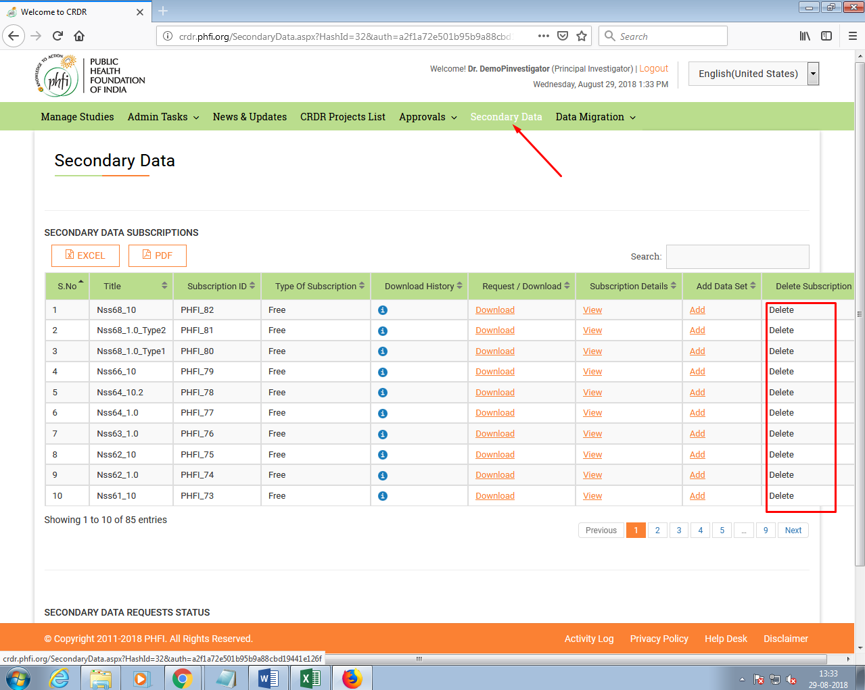

Result: Pass

Step 03: On clicking on delete, A validation message will appear on screen. On Clicking “Ok” all the related datasets will get deleted from the system.

